5 WEB API Hands-on
ASP.NET Core Web API – JWT Authentication
1. Objective
- Explain CORS enablement for Web API access.
- Demonstrate security in Web API using JWT Bearer authentication.
- Use the Authorize and AllowAnonymous attributes.
- Validate JWT token, roles, and token expiration.
- Test the API using Swagger and Postman.

2. Procedure / Implementation
2.1 JSON Web Token (JWT)
Configured JWT authentication in Program.cs by adding AddAuthentication(), AddJwtBearer(), and UseAuthentication(). The issuer, audience, and secret key were configured for token validation.
Created an AuthController with the AllowAnonymous attribute. Implemented the GenerateJSONWebToken() method to generate a JWT containing UserId and Admin role claims.

2.2 Authorization using JWT
Removed the CustomAuthFilter from the EmployeeController and applied the Authorize attribute. Tested the GET action using Postman. Without a Bearer token, the API returned 401 Unauthorized. With a valid JWT token generated from the AuthController, the API returned 200 OK.

2.3 JWT Expiration
Modified the token expiration time to 2 minutes. After the token expired, the GET request returned 401 Unauthorized.

2.4 Role-Based Authorization
Applied the POC role in the Authorize attribute and verified that the request returned 401 Unauthorized. Added both Admin and POC roles in the Authorize attribute and verified that the request returned 200 OK.

3. Verification Results
Test | Expected Result | Observed Result
Generate JWT Token | JWT token generated successfully | Success
GET without Bearer token | 401 Unauthorized | Success
GET with valid JWT token | 200 OK | Success
GET with modified JWT token | 401 Unauthorized | Success
GET after token expiration | 401 Unauthorized | Success
GET with POC role | 401 Unauthorized | Success
GET with Admin and POC roles | 200 OK | Success

Screenshots

- Figure 1: JWT token generated successfully from AuthController.

- Figure 2: GET without Bearer Token (401 Unauthorized)

- Figure 3: GET with Valid JWT Token (200 OK)
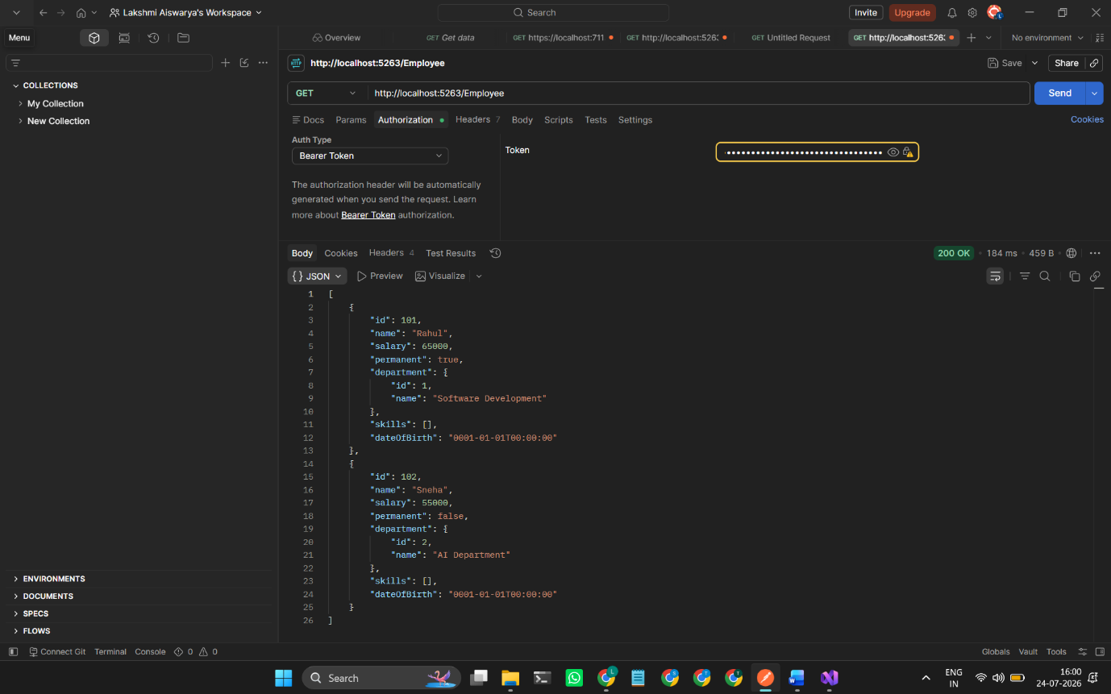


- Figure 4: Modified/Invalid JWT Token (401 Unauthorized)
- Figure 5: JWT Expiration (401 Unauthorized)



Result
Successfully implemented JWT authentication and authorization in ASP.NET Core Web API. The API authenticated users using Bearer tokens, validated roles and token expiration, and was successfully tested using Swagger and Postman.

